# Decisions

* Send a link via what method
  + Email
  + SMS
  + QR Code
* How should we handle the switching between devices?
* Where in the flow should it be?

# Usage Stats

* 6.2% of total mobile audience in the US scanned a QR code with their mobile
  + 58% from home
  + 39% at a retail store
* 292 million people in North America use text messages — that’s 80% of the total population.
* With 68% of use, mobile push notifications are the most common authentication method.
* Insurance/Financial industry had around 50%
* About 3 in 5 consumers check their email on the go (mobile) and 75% of say they use their smartphones most often to check email. – Fluent “The Inbox report, Consumer perceptions of email” (2018)

QR

<https://internetretailing.net/themes/14m-americans-scanned-qr-and-bar-codes-with-their-mobiles-in-june-2011>

<https://econsultancy.com/the-pros-and-cons-of-qr-codes/>

SMS

<https://www.slicktext.com/blog/2018/11/44-mind-blowing-sms-marketing-and-texting-statistics/>

2FA Stats

<https://dataprot.net/statistics/two-factor-authentication-statistics/>

Email Stats

<https://www.emailmonday.com/mobile-email-usage-statistics/#growth>

# Pros and Cons of QR Codes

## Pros

* Ease of use
  + Saving the effort of remembering/typing in URL - works well for offline interactions (e.g. printed media)

## Cons

* As Tim Dunn thoroughly explained in a recent article about QR codes, the process of scanning can prove to be tedious and time-consuming. Mobile users have to
  + Take out their phone
  + Launch their reader
  + **Scan the code** (the main difference - is it easier to do this or to click a link?)
  + Wait for it to direct them to the landing page.
* An increasing number of businesses make use of QR codes, but only a handful of the population uses them (comScore).

<https://www.funkykit.com/news/miscellaneous/advantages-disadvantages-qr-codes/>

# Conclusion

* The ideal solution minimizes the effort for the user
* All else being equal (assuming correct setup), there is not much difference in effort between using the three in this case
* However, there is some variability in usage/phone set ups that may make some difference in the amount of effort
  + Email requires it to be set up on mobile, which not everyone will, also people have multiple emails
  + QR codes is less familiar/used and there is a variability in terms of whether or not the code will scan easily, also accessibility?
  + Usage wise, SMS is the most widely used and guaranteed to be set up and to trigger a notification

# Accessibility of QR Codes

Codewords are 8 bits long and use the Reed–Solomon error correction algorithm with four error correction levels. The higher the error correction level, the less storage capacity. The following table lists the approximate error correction capability at each of the four levels:

Level L (Low) 7% of codewords can be restored.

Level M (Medium) 15% of codewords can be restored.

Level Q (Quartile) 25% of codewords can be restored.

Level H (High) 30% of codewords can be restored.

<https://otswithapps.com/2012/01/01/qr-codes-as-assistive-technology/>

There appear to be no accessibility issues (vision or motor skills) with QR codes, we just need to make sure it is large.

<https://engineering.stackexchange.com/questions/12378/how-reliable-is-a-qr-code-reader>

<https://www.localguidesconnect.com/t5/General-Discussion/Accessibility-Uncovered-Assistive-Tech-QR-Codes/td-p/1883548>

How to make it more accessible (suggesting a link option)

<https://stackoverflow.com/questions/59066426/how-to-enhance-the-accessibility-of-qr-codes-on-the-web>

# Previous Testing

* Attitudes
  + Primary motivation is not having to go into the branch
  + Reservations regarding security and privacy
    - “I would choose the photo option, but I would like some reassurances on security first”
    - “What if someone found a photo of me online? Would they be able to open an account in my name?”
    - “If I sign with another bank account, what information are they going to be able to see?”
  + If these reservations are stronger than their desire to not go into the branch, they will abandon so we need to reassure them and minimise their reservations
* Usability Insights
  + Electronic signature could prove difficult (or be perceived as such) by users
  + Points where reassurance is required
    - Storing ID and photo
    - Potential for fraud
    - How their info is being used
    - Keeping everything inside CIBC

# Key Design Principles

* **Composition**: how devices and functionality are organized
  + Quickly establish mental model - roles of each of the devices
  + Desktop is the primary device, we are not done with it even though we are changing devices
  + Phone is a complementary device, we should focus on it for now but we will return to the desktop afterwards
* **Consistency** of interfaces across different devices
  + Consistent terminology
  + Platform conventions
  + Consistent aesthetic styling
* **Continuity** of content and data to ensure smooth transitions between platform
  + Visibility of system status
  + Users need to know when to switch to/from mobile and they need to know whether what they’re doing is working/not working
  + State of the page on desktop should change to reflect the current state even though the interaction is happening on mobile
  + Perform actions optimistically where possible

<https://www.oreilly.com/library/view/designing-for-the/9781491971468/ch05.html#handling_cross-device_interactions_and_t>

# Examples

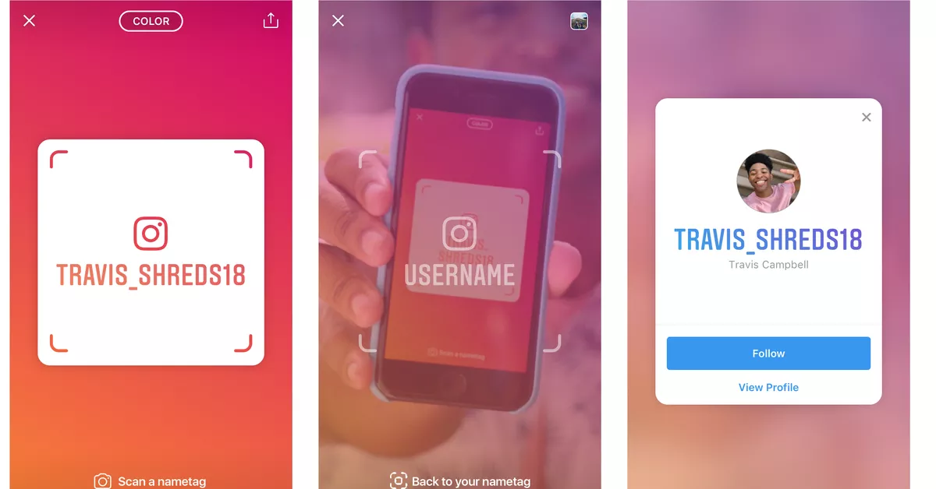

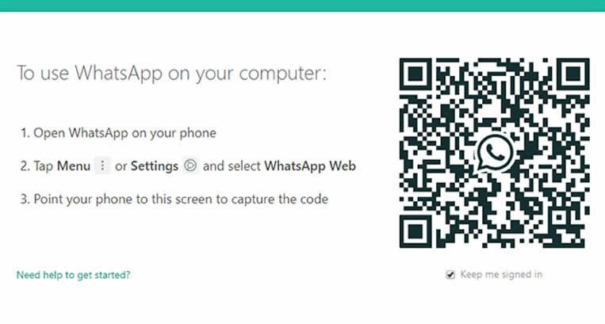



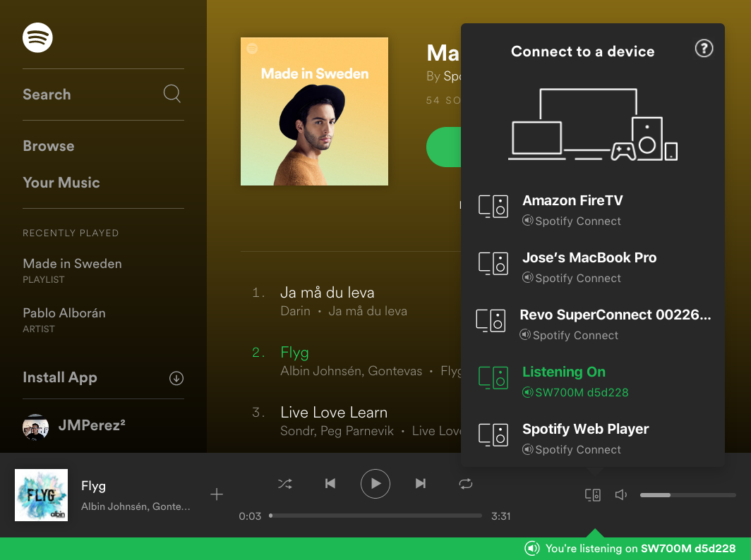

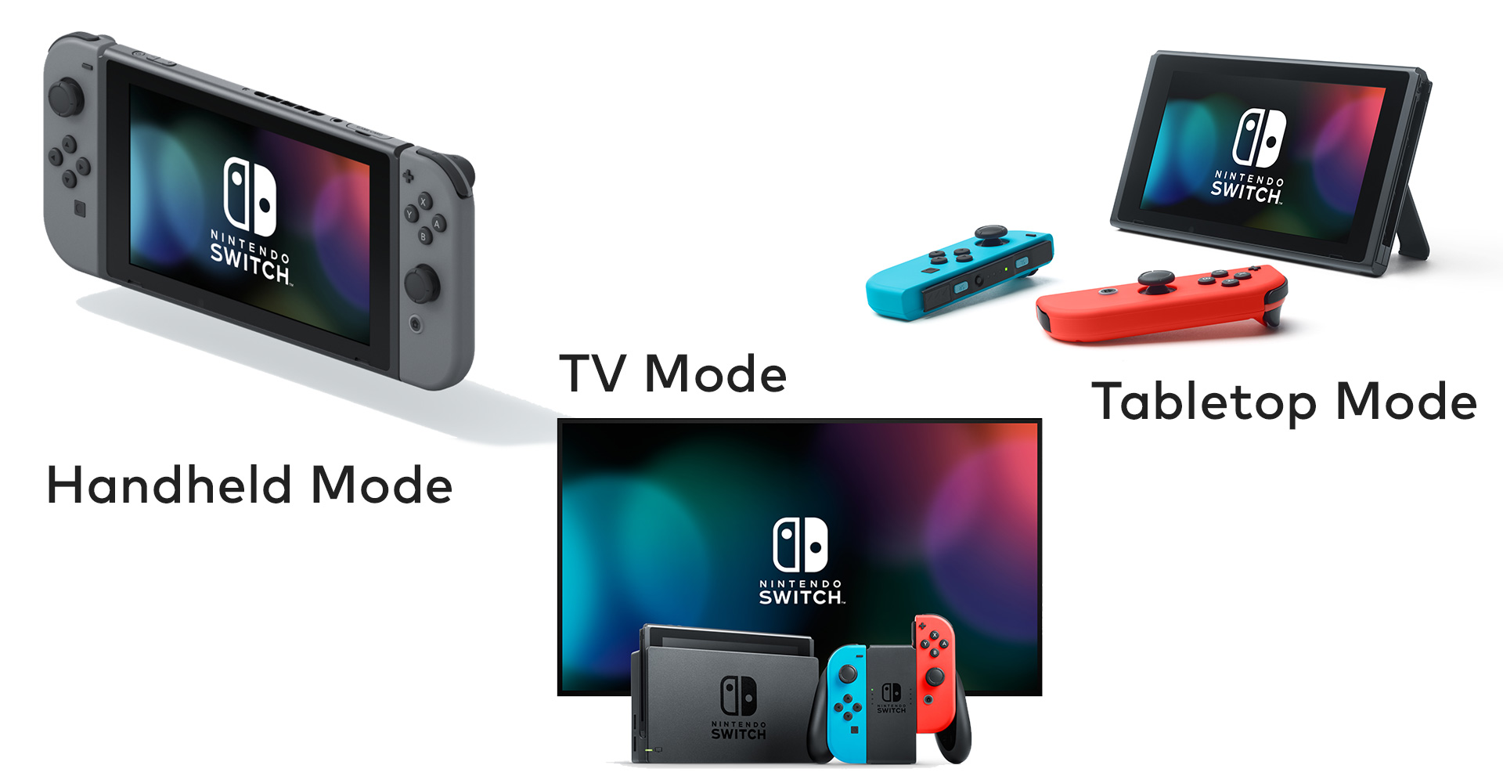

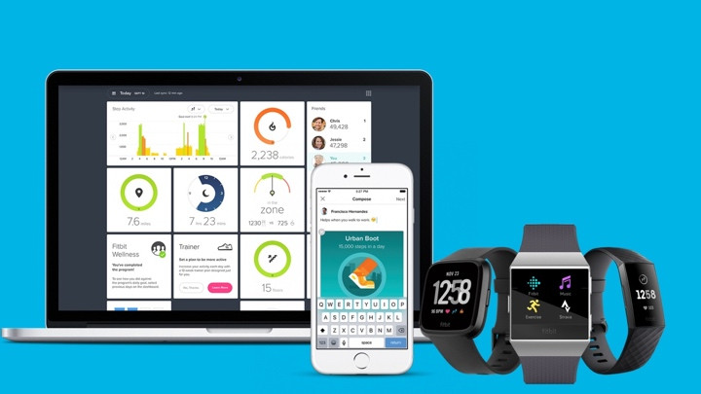



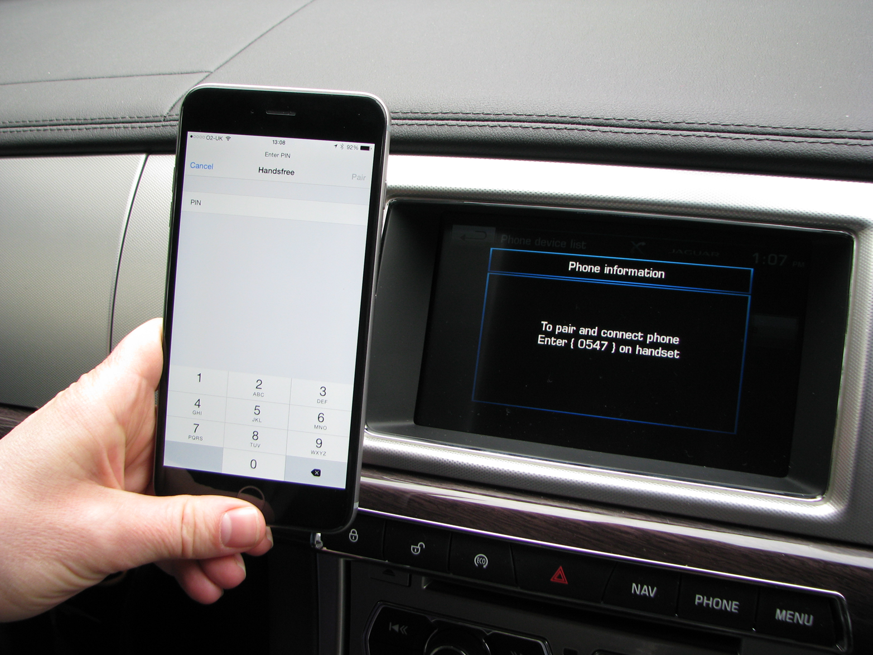

# Other Links

<https://dl.acm.org/doi/abs/10.1145/2742647.2742650>

<https://dl.acm.org/doi/abs/10.1145/1971519.1971593>

<https://dl.acm.org/doi/abs/10.1145/3351284>

[http://radar.oreilly.com/2015/03/cross-device-interactions-and-interusability.htl](http://radar.oreilly.com/2015/03/cross-device-interactions-and-interusability.html)

<https://hci.uni-konstanz.de/en/research/research-projects/completed-research-projects/cross-device-interaction/>

<https://www.oreilly.com/library/view/designing-for-the/9781491971468/ch05.html>

<https://www.slideshare.net/anais_bejarano/designing-multi-device-experiences-59484751>

<https://www.semanticscholar.org/paper/The-4C-framework%3A-principles-of-interaction-in-S%C3%B8rensen-Raptis/75a42ac554b2441201c8bc0e4a1abcdca47e5a20>

<https://www.slideshare.net/solmesz/ux-in-2018-designing-multidevice-multiplatform-expreriences>